14-108 Seongmin Jeon

Forensic Science – Section 2

Pre Laboratory Report – Week 5

Topic: Personal Identification Using Fingerprint

1. Principle of Fingerprint

A fingerprint is a unique pattern on the first joint of finger or thumb. It is composed of friction ridges and furrows. Though impression from toes, palms and feet are also unique, fingerprint is usually used for personal identification. The study of fingerprint classification is called “Dactyloscopy” (Derived from Greek words, Dactylos means a finger, Skopein means to examine). Dactyloscopy is used as a procedure of personal identification based on study about unique patterns of fingerprint. There are three dogmatic principles of finger prints; the principle of constancy, the principle of variation, the principle of infallibility.

-Principle of Constancy

A fingerprint never changes during an individual’s lifetime. (Actually, it can change little bit.) Ridges and furrows on fingertips are fixed at the third month of embryonic period even before birth and immutable, perennial, individual until the decomposition starts after death except for the size. Almost only cause of fingerprint alteration is obscuration by deep tissue damage like burns. However, these obscured fingerprint can also be useful for personal identification.

-Principle of Variation

Any fingerprint is unique itself. None of fingerprints of different person, monovular twin, and even neighboring fingers of same person have identical print. So a fingerprint is an individual characteristic.

-Principle of Infallibility

|  |  |
| --- | --- |
| **Original Fingerprint** | **Forged Fingerprint** |
| 1. Ridges are life-like (somewhat round and soft) | 1. Ridges are sharp |
| 2. The swear pores dotting the ridges are well defined and visible | 2. Swear pores dotting the ridges are absent and not easily found |

Fingerprints cannot be forged with the following reasons. Forged fingerprints shows a huge difference with original fingerprint.

Of all the methods of identification, fingerprinting has proved to be the most trustworthy because no two individuals have identical fingerprints and it is almost impossible to forge a fingerprint.

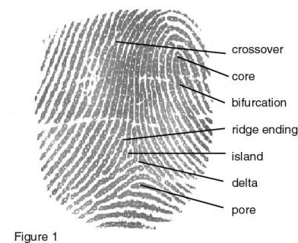

2. Fingerprint Detection method

There are two kinds of fingerprint exist: patent(visible) prints are made when pigmented substances like blood, dirt, or ink is transferred from a finger to a surface, latent(invisible) prints are made when body’s natural oil or sweat on fingertip is transferred to a surface. Patent prints are easy to find and detect, but latent prints, since they are invisible, are not readily detected and need special treatments.

-Collecting Patent Fingerprint

Collecting patent print is straight forward to taking a high resolution photography in forensic measurement scale. Then it is magnified and investigated.

-Collecting Latent Fingerprint

We need special treatments to collect latent fingerprint. The most simple method is dusting a smooth, nonporous surface with fingerprint powder; black granular, aluminum flake, black magnetic, et cetera. If any prints appear after applying powder, they are photographed and lifted from the surface with clear adhesive tape and preserved. But the biggest problem of fingerprint powder is that it can contaminate all other evidence and disrupt all chances to perform any other techniques. So before using powder method, different methods like alternative light source or cyanoacrylate(commonly known as “Super Glue”).

1) Alternative Light Source(ALS)

Laser or LED devices with particular wavelength can be used for examining any likely surfaces like window, doorknobs, doors, desk, keyboard, and so on. With several different lights of wavelengths by filters providing diverse range of spectra which can be photographed, fingerprint can be detected and dyed afterward for more clear photograph. For example, investigators may use blue light with orange filter to find fingerprints on objects like computer equipment, desks, chairs at the scene.

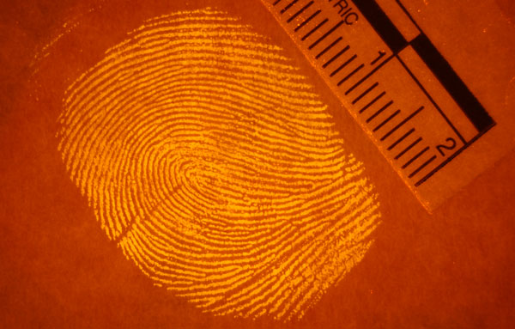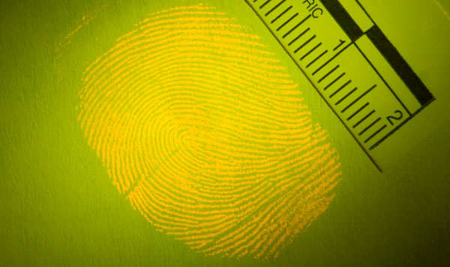

2) Super Glue(Cyanoacrylate)

Though the upper two are kind of a method to reveal the fingerprints, but here is better one. Most widely employed technique is fuming a cyanoacrylate compound (better known as “Super Glue”). When this compound is fumed, it reacts with the chemicals in the fingerprint and polymerizes into a white deposit. It is called super glue because it sticks and reacts really well with fingerprint. However a problem exists here. Since the compound formed is white, if the fingerprint support is light color, there will be ambiguity between the support and fingerprint itself. Similarly, if the fingerprint is very light, the compound will be too tenuous to get a good image. But this problem can be solved by coloring the fingerprint and not be troublesome.

Cyanoacrylate

Nevertheless, severe problem is post-treatment. The products are toxic and carcinogenic. The post treatment process require up to 48 hours and DNA of fingerprint sample can be destroyed by its long time. To solve these problems, in 2013, new original method to directly detect the latent prints have been invented by Laboratoire de Photophysique et Photochimie Supramoléculaire et Macromoléculaire. To manage cyanoacrylate, they combined it with a molecule of the tetrazine family, the smallest fluorescent colorants known to date. Tetrazine molecules are fumed along with the cyanoacrylate onto the fingerprint support and adhere to the deposit. In this way, using a simple UV lamp or forensic lighting techniques, the fluorescent traces are visible and can be photographed.



3. Henry’s Fingerprint Classification

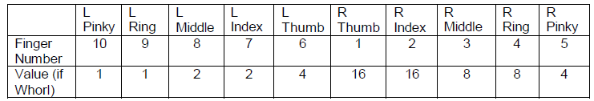

Henry’s fingerprint classification system is seldom used today, but it may have been used to classify fingerprints in cases of unidentified persons in years past. Because it might still be encountered, familiarity with it is prudent. As with all fingerprint classification systems, the fingers are numbered 1 through 10, with 1 being the right thumb and 6 being the left thumb. In the Henry system, fingers that have a whorl pattern are used to define a primary grouping for the set of fingerprints. A number is assigned to those fingers that have a whorl pattern like suggested as table above.

Henry’s has classified fingerprints briefly into three types: arches, whorls, and loops. After numbering all the fingers, it is determined for each finger if its basic pattern is an arch, a whorl or a loop. The results can be reported with 10 consecutive letters starting from Finger 1 and going to Finger 10, such as AUUWUAUAWU. 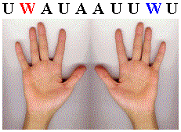

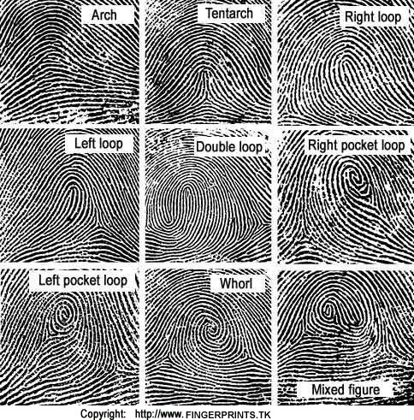

From this, a finger value is then calculated. Fingers that do not have a whorl are given a finger value of 0. Only fingers with a whorl pattern are assigned a number other than 0. Finally, a primary grouping is established using the following formula:

$$M=\frac{1 + (The sum of finger values for the evennumbered fingers)}{1 + (The sum of finger values for the oddnumbered fingers)}$$

For more complicated classification:

Each hand is represented by five syllables, one syllable for each finger, with each syllable separated by a hyphen. Syllables were constructed from an established list of 21 consonants and 6 vowels representing set fingerprint pattern characteristics. With this method, about 17 trillion classification is available.



4. History of Application

* The ancient Babylonians pressed the tips of their fingertips into clay to record business transactions.
* The Chinese used ink-on-paper finger impressions for business and to help identify their children.
* In 1882, Gilbert Thompson of the U.S. Geological Survey in New Mexico, used his own thumb print on a document to help prevent forgery. This is the first known use of fingerprints in the United States.

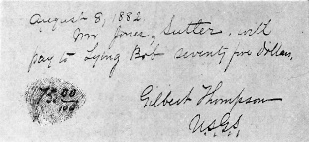

* In Mark Twain's book, "Life on the Mississippi", a murderer was identified by the use of fingerprint identification. In a later book, "Pudd'n Head Wilson", there was a dramatic court trial on fingerprint identification.

5. Reference

<https://forensics.knoji.com/the-three-dogmatic-principles-of-fingerprints/>

<http://www.forensicsciencesimplified.org/prints/principles.html>

<http://www.forensicsciencesimplified.org/prints/how.html>

<http://www.sciencedaily.com/releases/2013/10/131024102046.htm>

<https://identifyus.org/help/FPinformation.pdf>

<http://science.howstuffworks.com/fingerprinting3.htm>